Screen Sharing with Skype for Business
1.Click on the Windows button at the bottom left corner of the screen and type “Skype for Business”
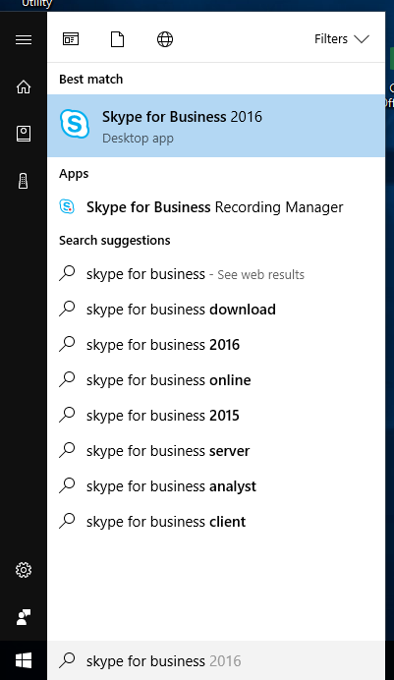
2. Sign in with Galloway school email credentials.
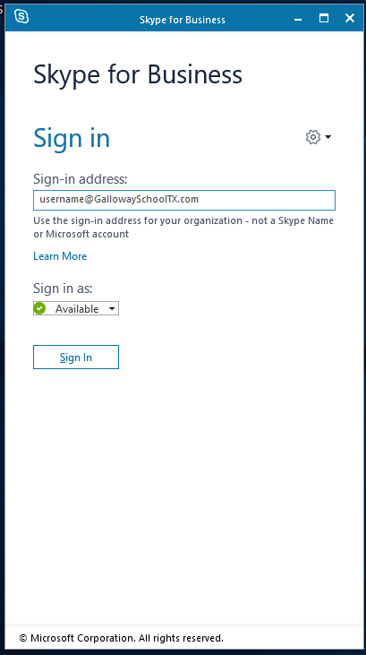

3. Search for the contact you’re wanting to connect with.
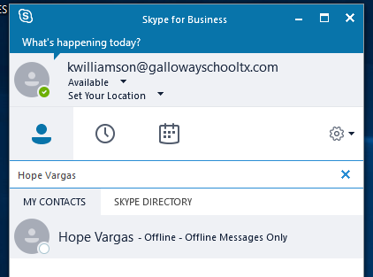
4. Click the button with a screen and arrow pointing out of it. Clicking on “Share your Desktop…” will enable screen sharing.
