Steps to Factory Reset Your iPad
This will erase all content on the iPad!
Send any information you do not want to lose to yourself.

- Tap on the Settings App on the home screen. 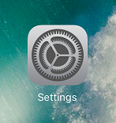

- Click on the General Tab on the left, then scroll down to reset on the right side.
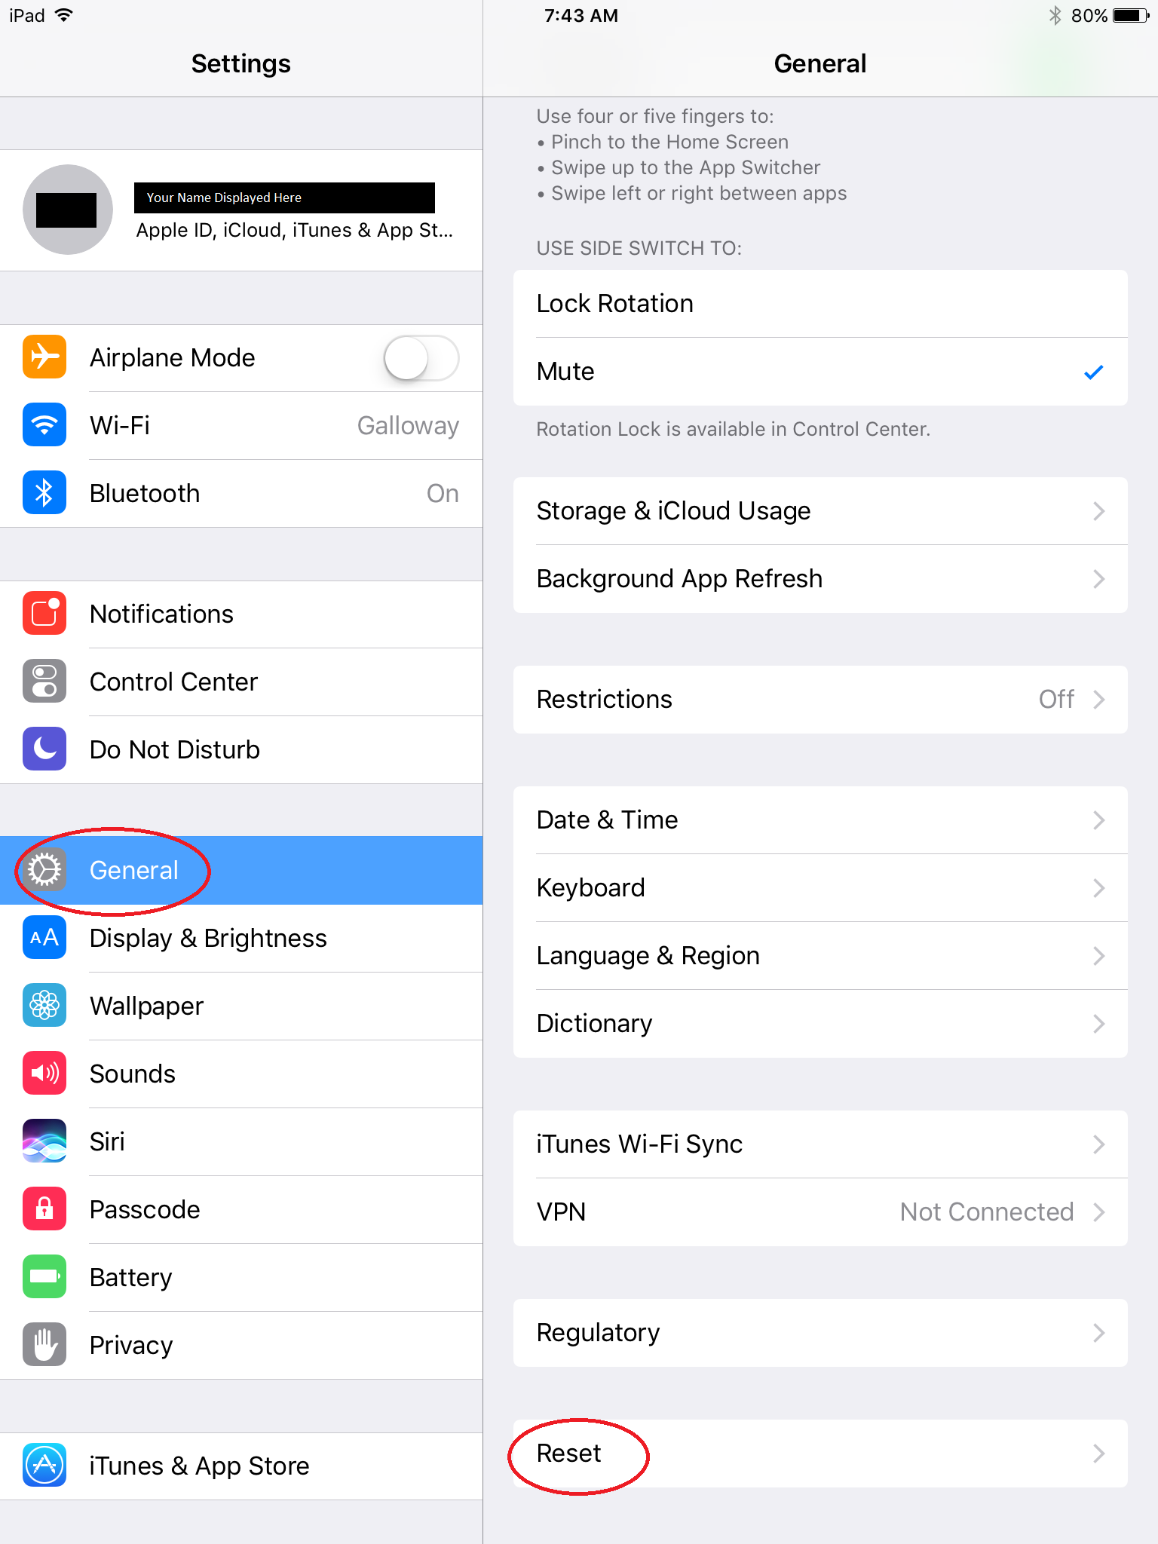
- Click on “Erase All Content and Settings.” You will be asked to enter your Apple login to confirm the reset.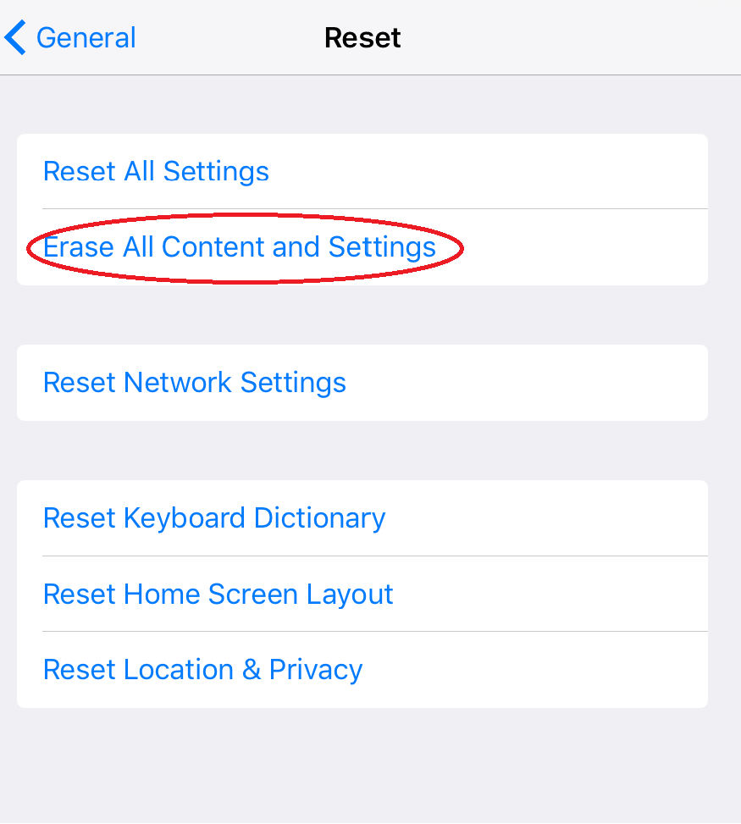
- Once the reset is completed, the “Hello, Welcome to your new iPad!” screen should display. You have successfully reset the iPad!

